**Haar cascade face-eye detection using python opencv**

Now we have to download PyCharm after that I have to download the opencv package from the setting then add it to my program

After that in order to do object recognition/detection with cascade files, you first need cascade files. For the extremely popular tasks, these already exist. Detecting things like faces, cars, smiles, eyes, and license plates for example are all pretty prevalent. We can use Google to find various Haar Cascades of things you may want to detect.

I downloaded the haarcascade_eye.xml and haarcascade_frontalface_default.xml from the links

* (frontal face default)

<https://github.com/opencv/opencv/blob/master/data/haarcascades/haarcascade_frontalface_default.xml>

* (eyes detections) <https://github.com/opencv/opencv/blob/master/data/haarcascades/haarcascade_eye.xml>

After that I wrote the python code:

import numpy as np

import cv2

# multiple cascades: https://github.com/Itseez/opencv/tree/master/data/haarcascades

#https://github.com/Itseez/opencv/blob/master/data/haarcascades/haarcascade_frontalface_default.xml

face_cascade = cv2.CascadeClassifier('haarcascade_frontalface_default.xml')

#https://github.com/Itseez/opencv/blob/master/data/haarcascades/haarcascade_eye.xml

eye_cascade = cv2.CascadeClassifier('haarcascade_eye.xml')

cap = cv2.VideoCapture(0)

while 1:

ret, img = cap.read()

gray = cv2.cvtColor(img, cv2.COLOR_BGR2GRAY)

faces = face_cascade.detectMultiScale(gray, 1.3, 5)

for (x,y,w,h) in faces:

cv2.rectangle(img,(x,y),(x+w,y+h),(255,0,0),2)

roi_gray = gray[y:y+h, x:x+w]

roi_color = img[y:y+h, x:x+w]

eyes = eye_cascade.detectMultiScale(roi_gray)

for (ex,ey,ew,eh) in eyes:

cv2.rectangle(roi_color,(ex,ey),(ex+ew,ey+eh),(0,255,0),2)

cv2.imshow('img',img)

k = cv2.waitKey(30) & 0xff

if k == 27:

break

cap.release()

cv2.destroyAllWindows()

Result:

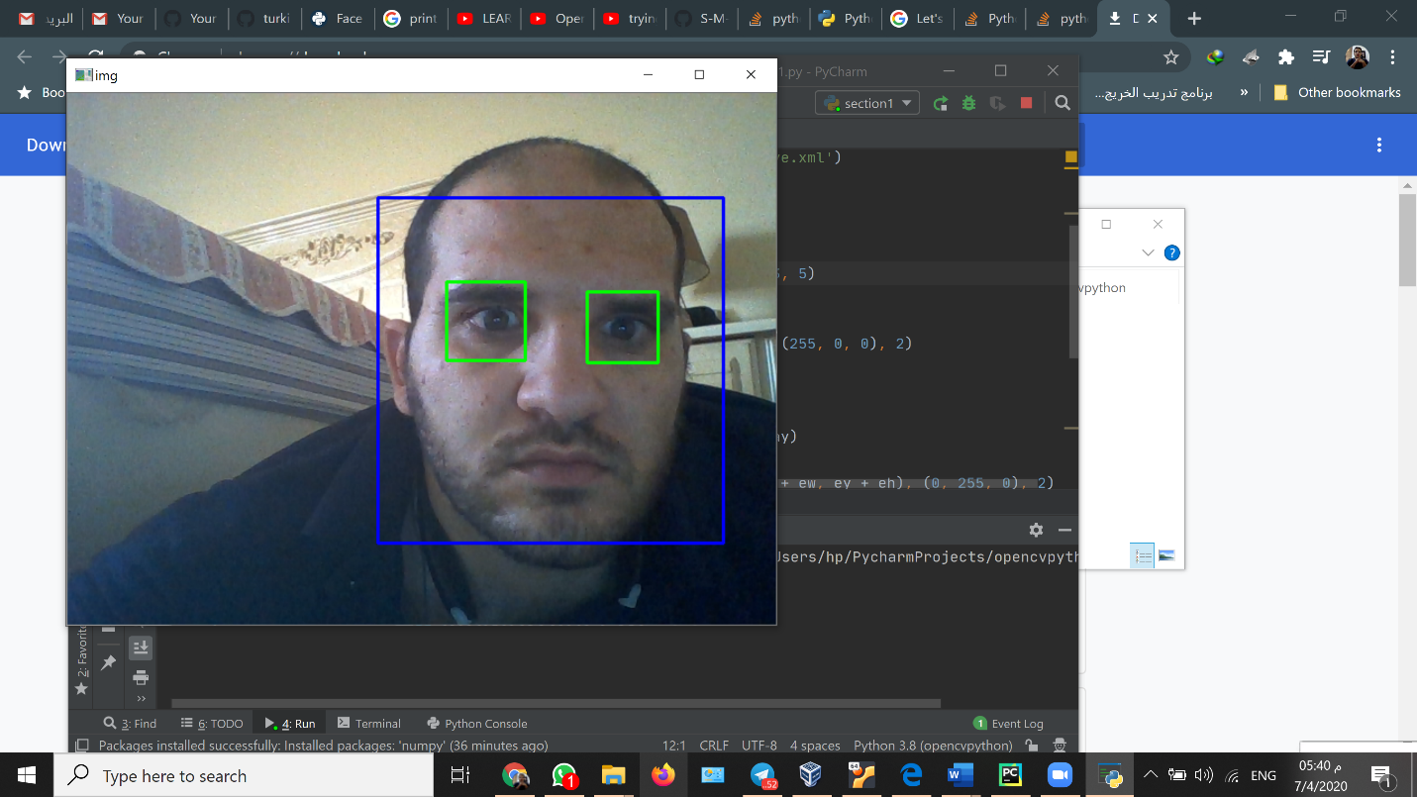

As we see in the result that it worked well and It detects my eyes and face

Not bad. You may notice I had to remove my glasses. These caused some trouble. My mouth also was detected pretty often as eyes, sometimes even a face, but you get the idea. Facial hair and other things can often fool rudimentary face detection, and even advanced. Skin color can also cause a lot of trouble, as we often try to simplify images as much as possible, thus losing a lot of color values.